GMF 10 Week 1 (April 6-9, 2020) ANSWERS

Instructions: Please complete the following questions by researching online and then turn them in on Teams when finished.
Angles:
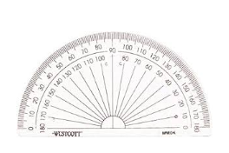
- What is the definition of an angle?
Two rays that meet at a point called the vertex

- We measure angles with an instrument called a ____protractor_________.

- Name and describe each of the following types of angles. Give an example of that type of angle from your house (first one is done as an example)
 | Type of angle | description | example from my house
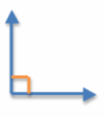 | right angle | measures exactly 90° | every wall in my house meets at a right angle
 | reflex angle | greater than 180° and less than 360° | the outside angle of the top of my roof
 | obtuse angle | greater than 90° and less than 180° | lazyboy chair when tipped back
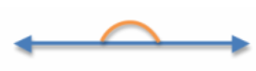 | straight angle | measures exactly 180° | the floor
 | acute angle | less than 90° | the clothes drying rack

- Reference angles: angles that are easy to visualize, which we use to estimate a given angle.

Reference angles:

Use the above reference angles to estimate the measurements in degrees, for the following angles. Include the type of angle (the first is done as an example)
Angle Type: Acute | Angle Type: Acute | Angle Type: Obtuse
Estimate: 70° (looks less than 90°, but more than 60°) | Estimate: 25° | Estimate: 110°

Angle Type: Acute | Angle Type: Obtuse | Angle Type: Reflex
Estimate: 65° | Estimate: 100° | Estimate: 300° (a full circle is 360°, this looks to be about 60° less than that)

- Complimentary and Supplementary Angles:
Supplementary angles are two angles whose sum is 180 degrees while complementary angles are two angles whose sum is 90 degrees.

Watch this video (https://www.youtube.com/watch?v=h9zUbWPqVpc ) and then answer the following questions (note for video: adjacent just means next to each other)

  - What angle is supplementary to 60°? ____120°____
  - What angle is complementary to 30°? ___60°_____
  - 20° and 70° together are which types of angles? ________complementary_________
  - 120° and 60° together are which types of angles? ________ supplementary _________

Use this diagram to answer the rest:
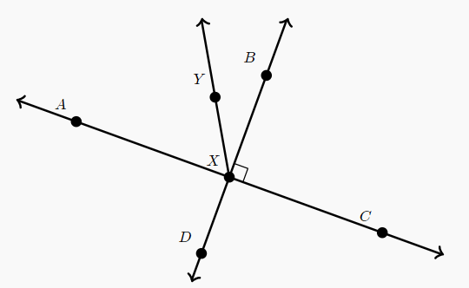
  - Angle AXY is ________ supplementary _________ to angle CXY
  - Angle AXY is _______ complementary __________ to angle BXY
  - If angle DXY is 140° then what is the measurement of angle BXY? ____40°____
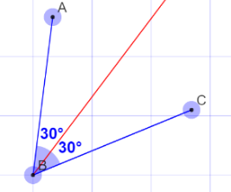
- Angle bisectors: A line that splits an angle into two equal angles.

What would be the angle measurement of the bisector of the following angles:

  - An angle that measures 100° would have a bisector of ___50°____
  - An angle that measures 68° would have a bisector of ___34°____
  - An angle that measures 70° would have a bisector of ___35°____
  - An angle that measures 16° would have a bisector of ___8°____
  - An angle that measures 240° would have a bisector of __120°_____

- Watch the following video and then describe, in your own words, how to bisect an angle with a compass. https://www.youtube.com/watch?v=nysMOfPsAfI

Set your compass so that the gap between the pivot point and pencil is a few cm. Put the pivot point on the vertex. Mark each side of the angle with the pencil. Adjust the compass so that the gap between the pivot point and pencil is over half the distance between the tow marks on the sides of the angle. Put the pivot point on one mark and mark off a short arc inside the angle. Put the pivot point on the other mark and mark off another short arc inside the angle, to intersect the first arc. Draw a line segment from the vertex to the point of intersection.

Great work!! You did your first online learning math assignment

