GMF 10 Week 1 (April 6-9, 2020)

Instructions: Please complete the following questions by researching online and then turn them in on Teams when finished.
Angles:
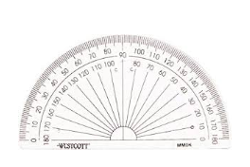
- What is the definition of an angle?

- We measure angles with an instrument called a _____________.

- Name and describe each of the following types of angles. Give an example of that type of angle from your house (first one is done as an example)
 | Type of angle | description | example from my house
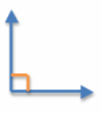 | right angle | measures exactly 90° | every wall in my house meets at a right angle
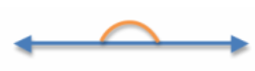

- Reference angles: angles that are easy to visualize, which we use to estimate a given angle.

Reference angles:

Use the above reference angles to estimate the measurements in degrees, for the following angles. Include the type of angle (the first is done as an example)
Angle Type: Acute | Angle Type: | Angle Type:
Estimate: 70° (looks less than 90°, but more than 60°) | Estimate: | Estimate:

Angle Type: | Angle Type: | Angle Type:
Estimate: | Estimate: | Estimate:

- Complimentary and Supplementary Angles:
Supplementary angles are two angles whose sum is 180 degrees while complementary angles are two angles whose sum is 90 degrees.

Watch this video (https://www.youtube.com/watch?v=h9zUbWPqVpc ) and then answer the following questions (note for video: adjacent just means next to each other)

  - What angle is supplementary to 60°? ________
  - What angle is complementary to 30°? ________
  - 20° and 70° together are which types of angles? _________________
  - 120° and 60° together are which types of angles? _________________

Use this diagram to answer the rest:
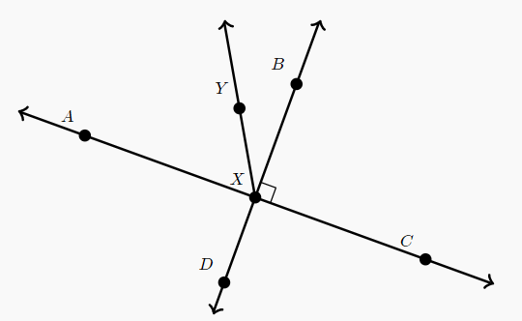
  - Angle AXY is _________________ to angle CXY
  - Angle AXY is _________________ to angle BXY
  - If angle DXY is 140° then what is the measurement of angle BXY? ________
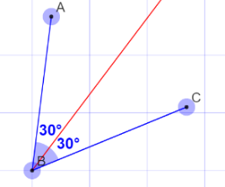
- Angle bisectors: A line that splits an angle into two equal angles.

What would be the angle measurement of the bisector of the following angles:

  - An angle that measures 100° would have a bisector of ___50°____
  - An angle that measures 68° would have a bisector of _______
  - An angle that measures 70° would have a bisector of _______
  - An angle that measures 16° would have a bisector of _______
  - An angle that measures 240° would have a bisector of _______

- Watch the following video and then describe, in your own words, how to bisect an angle with a compass. https://www.youtube.com/watch?v=nysMOfPsAfI

Great work!! You did your first online learning math assignment

