GMF 10 Week 2 (April 14-17, 2020) ANSWERS

Instructions: Please complete the following questions by researching online and watching video links and then turn them in on Teams when finished.
Parallel Lines and Transversals:
- Watch the following video and as you’re watching, answer the questions below. You may need to pause the video or watch multiple times. https://www.youtube.com/watch?v=6RMN5Pf1fHU
  - What makes two lines parallel?
lines that do not intersect or ever meet
  - What is a transversal? a line that cuts through two parallel lines

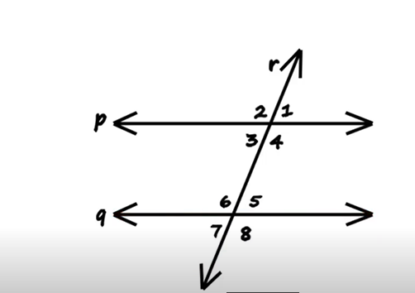
  - ∠1 = ∠5 , these are called ________corresponding____ angles

  - What other pairs of angles in the diagram are corresponding angles?
∠2 = ∠6 ∠3 = ∠7 ∠4 = ∠8
  - Which angles are interior angles and why are they called interior angles?
∠3, ∠4 , ∠5 and ∠6 because they are inside the two parallel lines
  - What are the two types of interior angles? How can you distinguish between them?
Alternate interior – opposite sides of the transversal, not right next to each other & Consecutive interior – same side of the transversal
  - In the diagram, which pairs of angles are alternate interior?
∠3 and ∠5 also ∠6 and ∠4
  - In the diagram, which pairs of angles are consecutive interior?
∠3 and ∠6 also ∠5 and ∠4
  - Describe vertically opposite angles. What are the four pairs of vertically opposite angles in the diagram?
They are across from each other. ∠3 and ∠1, ∠2 and ∠4, ∠7 and ∠5, ∠6 and ∠8
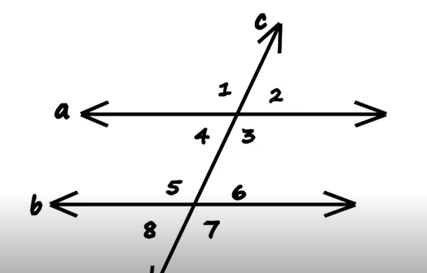
  - ∠2 = ∠6 because they are ___________corresponding angles___________
  - ∠6 = ∠8 because they are _________vertically opposite angles_____________
  - ∠4 = ∠8 because they are __________ corresponding angles ____________
  - ∠1 = ∠5 because they are __________ corresponding angles ____________
  - ∠7 = ∠5 because they are ___________ vertically opposite angles ___________
  - ∠3 = ∠7 because they are _________ corresponding angles _____________

- Watch the following video and as you’re watching, answer the questions below. You may need to pause the video or watch multiple times. https://www.youtube.com/watch?v=5PcMbN46NMA
  - Which street in the introduction is considered the “transversal”? Broadway
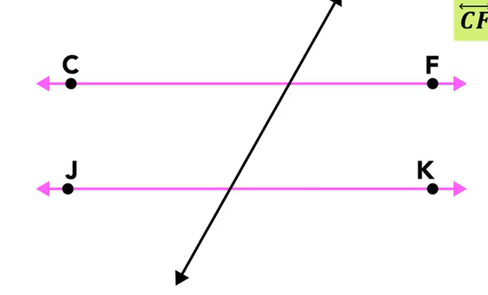
  - What does congruent mean? (may need to look it up) - it means “the same”
  - Explain why the unknown angle (the acute angle) is 58°. Use the word supplementary in your answer.
If the obtuse angle is 122°, and the obtuse angle and acute angle together from a straight angle, which measures 180°, then those two angles are supplementary, and to find the acute angle, you subtract 122° from 180°, which equals 58°.
  - Explain the X’s and O’s mindset.
Used to differentiate between the obtuse and acute angles using diagonals. Label all acute with one letter, and the obtuse angles with the other letter. x’s are equal, o’s are equal, and a combination of the two equals 180°.
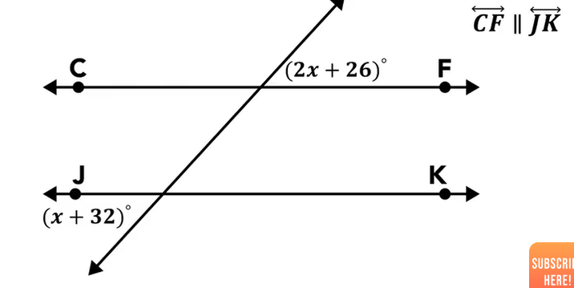
  - Show the steps to finding the value of “x” in the diagram above. What is the measure of the acute angles? What is the measure of the obtuse angles?
2x + 26 = x + 32  -x -x  x + 26 = 32  -26 -26  x = 6 | 2x + 26  =2(6) + 26  =12 + 26  =38$°$ | x + 32  =6 + 32  =38$°$

  - What are the measures of the acute and obtuse angles in the practice question below?

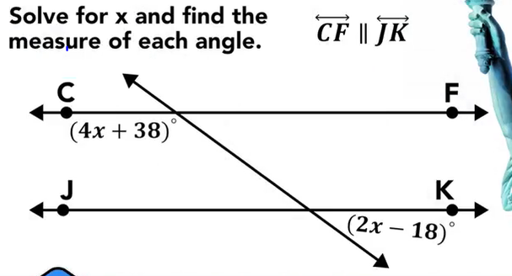
This is a little harder because these aren’t equal, but they do add to make 180°
180 – (4x + 38) = 2x – 18  180 – 4x – 38 = 2x – 18  142 – 4x = 2x – 18  +4x +4x  142 = 6x – 18  +18 +18  160 = 6x  /6 /6  x = $26,\overline{6}$ | 4x + 38  =4($26,\overline{6}$) + 38  =$144,\overline{6}°$ | 2x – 18  =2($26,\overline{6}$) – 18  =$35,\overline{3}°$

- Use what you learned in the videos to answer the following questions
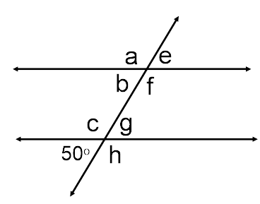
  - ∠g = _____50°_______ - reason : vertically opposite angles

  - ∠e= ______50°______ - reason : vertically opposite of a corresponding angle

  - ∠b= _____50°_______ - reason : corresponding angle

  - ∠h= _____130°_______ - reason : supplementary angle

- Find the measure of each angle indicated:
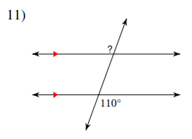 | 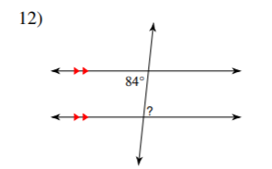 | 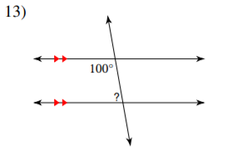
? = ___110°___ | ? = __84°____ | ? = __80°____

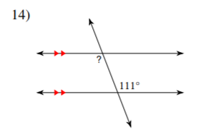 | 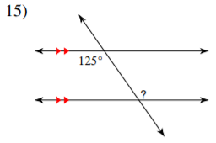 | 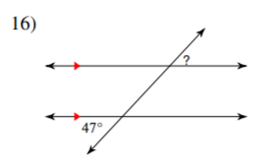
? = __111°____ | ? = __125°____ | ? = ___47°___

- Solve for x
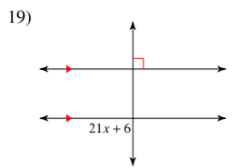 | 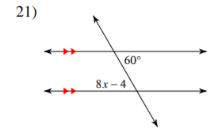 | 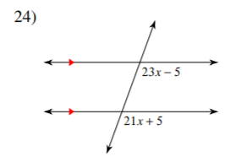
21x + 6 = 90  -6 -6  21x = 84  /21 /21  x = 4 | 8x – 4 = 60  +4 +4  8x = 64  /8 /8  x = 8 | 21x + 5 = 23x – 5  -21x -21x  5 = 2x – 5  +5 +5  10 = 2x  /2 /2  x = 5

- Find the measure of the angle indicated in bold.
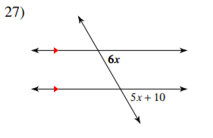 | (This is advanced)  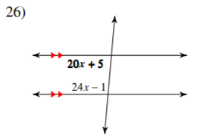
5x + 10 = 6x  -5x -5x  10 = x  6x  6(10) = 60°  5x + 10  = 5(10) + 10  = 50 + 10  = 60° | 180 – (24x – 1) = 20x + 5  180 – 24x + 1 = 20x + 5  181 – 24x = 20x + 5  +24x +24x  181 = 44x + 5  -5 -5  176 = 44x  /44 /44  x = $4$  20x + 5  =20(4) + 5  = 85°  24x – 1  = 24(4) – 1  = 96 – 1  = 95°

- Solve the angle puzzle below: (hint – you need to use your knowledge of right angles, supplementary angles and transversals through parallel lines to solve this)
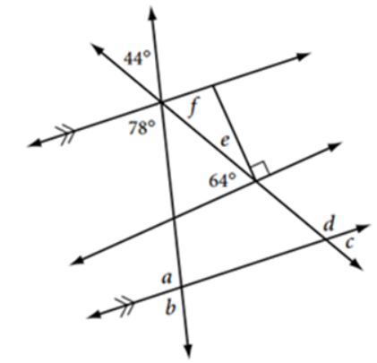 | a = ___102°____  b = ___78°____  c = ___58°____  d = ____122°___  e = ___26°____  f = ___58°____

