GMF 10 Week 2 (April 14-17, 2020)

Instructions: Please complete the following questions by researching online and watching video links and then turn them in on Teams when finished.
Parallel Lines and Transversals:
- Watch the following video and as you’re watching, answer the questions below. You may need to pause the video or watch multiple times. https://www.youtube.com/watch?v=6RMN5Pf1fHU
  - What makes two lines parallel?

  - What is a transversal?

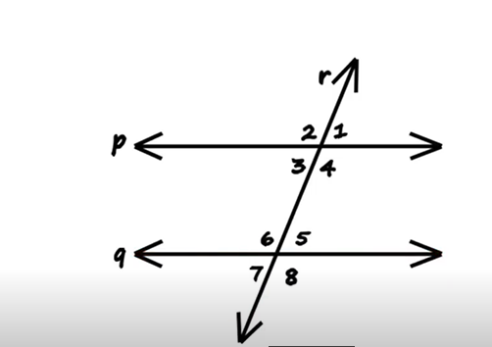
  - ∠1 = ∠5 , these are called _______________________ angles

  - What other pairs of angles in the diagram are corresponding angles?

  - Which angles are interior angles and why are they called interior angles?

  - What are the two types of interior angles? How can you distinguish between them?

  - In the diagram, which pairs of angles are alternate interior?

  - In the diagram, which pairs of angles are consecutive interior?

  - Describe vertically opposite angles. What are the four pairs of vertically opposite angles in the diagram?
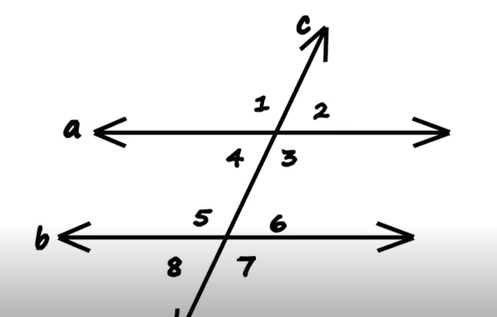
  - ∠2 = ∠6 because they are ______________________
  - ∠6 = ∠8 because they are ______________________
  - ∠4 = ∠8 because they are ______________________
  - ∠1 = ∠5 because they are ______________________
  - ∠7 = ∠5 because they are ______________________
  - ∠3 = ∠7 because they are ______________________

- Watch the following video and as you’re watching, answer the questions below. You may need to pause the video or watch multiple times. https://www.youtube.com/watch?v=5PcMbN46NMA
  - Which street in the introduction is considered the “transversal”?
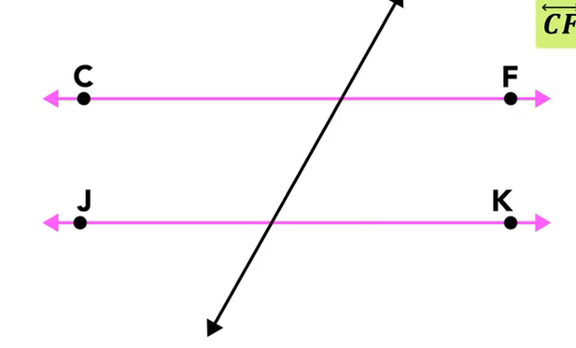
  - What does congruent mean? (may need to look it up)
  - Explain why the unknown angle (the acute angle) is 58°. Use the word supplementary in your answer.
  - Explain the X’s and O’s mindset.
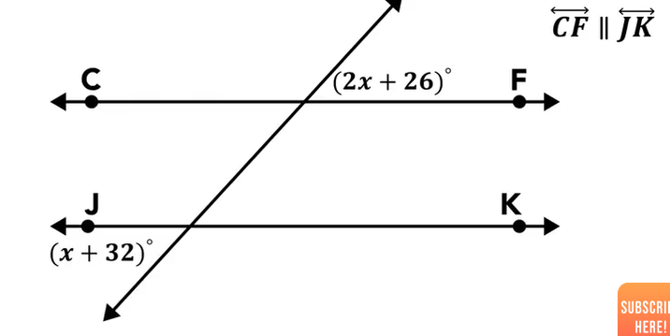
  - Show the steps to finding the value of “x” in the diagram above. What is the measure of the acute angles? What is the measure of the obtuse angles?

  - What are the measures of the acute and obtuse angles in the practice question below?

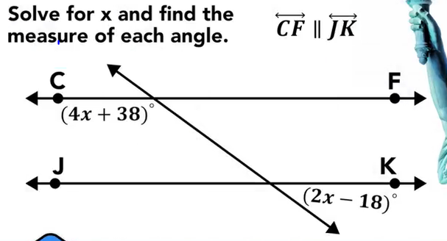
- Use what you learned in the videos to answer the following questions
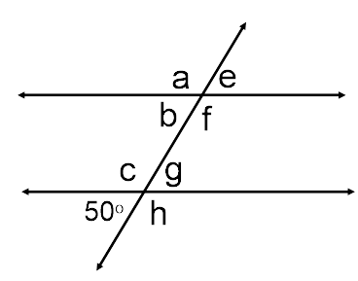
  - ∠g = ____________ - reason :

  - ∠e= ____________ - reason :

  - ∠b= ____________ - reason :

  - ∠h= ____________ - reason :

- Find the measure of each angle indicated:
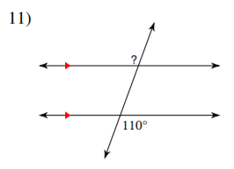 | 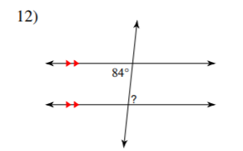 | 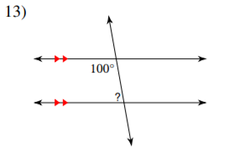
? = ______ | ? = ______ | ? = ______

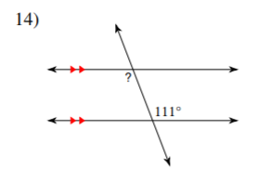 | 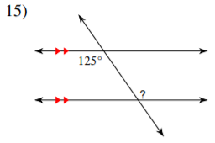 | 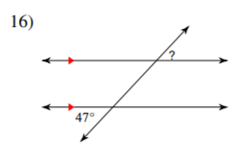
? = ______ | ? = ______ | ? = ______

- Solve for x
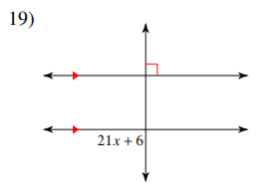 | 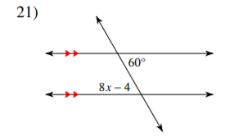 | 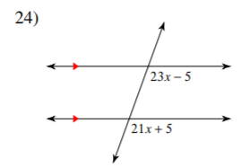

- Find the measure of the angle indicated in bold.
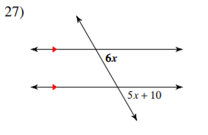 | (This is advanced)  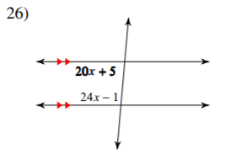

- Solve the angle puzzle below: (hint – you need to use your knowledge of right angles, supplementary angles and transversals through parallel lines to solve this)
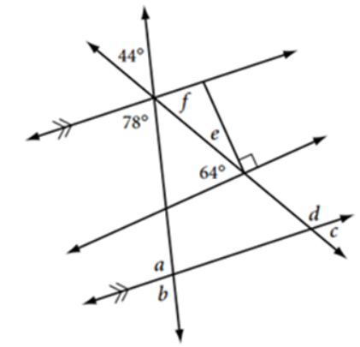 | a = _______  b = _______  c = _______  d = _______  e = _______  f = _______

