GMF 10 Week 3 (April 20-24, 2020) ANSWERS

Instructions: Please complete the following questions by researching online and watching video links. Please reach out to your teacher for help or guidance through email or Teams if needed. Live video tutorials are on Teams Wednesdays at 11am and will be recorded and posted on Teams to watch at your convenience.
Triangles
- Watch the following video on classifying triangles and as you’re watching, fill in the triangle names and describe it. You may need to pause the video or watch multiple times (yes, it says grade 5! it’s a review before we get into the harder stuff) https://www.youtube.com/watch?v=H62faKsyemc
by sides | by angles
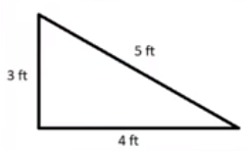  name: scalene  description: all side lengths are different | 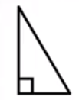  name: right triangle  description: has a 90° angle
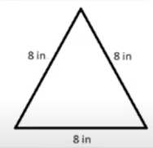  name: equilateral  description: all side lengths are equal | 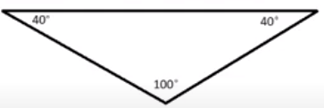  name: obtuse triangle  description: one of the angles is obtuse (over 90°)
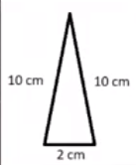  name: isosceles  description: two of the side lengths are the same (congruent) | 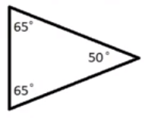  name: acute triangle  description: all 3 angles are acute (all are less than 90°)

- Classify the following triangles by sides and by angles
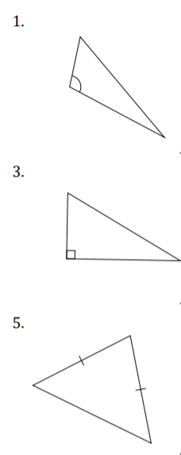  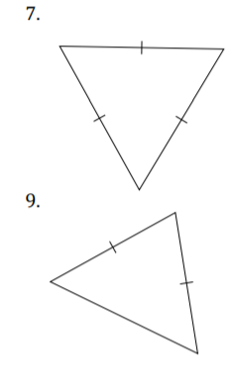 | ex: obtuse scalene | 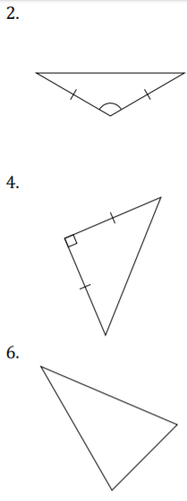  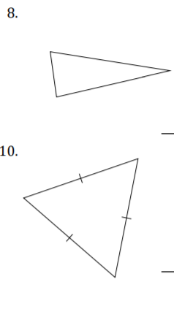 | obtuse isosceles
 | right scalene |  | right isosceles
 | acute isosceles |  | acute scalene
 | acute equilateral |  | acute scalene
 | acute isosceles |  | acute equilateral

- Find the missing angles. Reminder: the angles of a triangle always add to 180° and a flat angle also measures 180°. Write your answers in the table below the image.

Example: | a = 38° - because it’s an isosceles triangle (you can tell by the two hash marks on the sides of the triangle) so if the two sides are equal, the two angles are also equal.  b = 104° - because there are 180° in a triangle and 38° + 38° = 76°, which leaves 104° for the missing angle.  c = 104° - because it is vertically opposite of b, therefore they are equal.  d = 76° - because c/d or b/d are supplementary angles which add to 180°, 180° - 104° = 76°  e = 76° - supplementary (180°-104°) to c or b OR vertically opposite (equal) to d

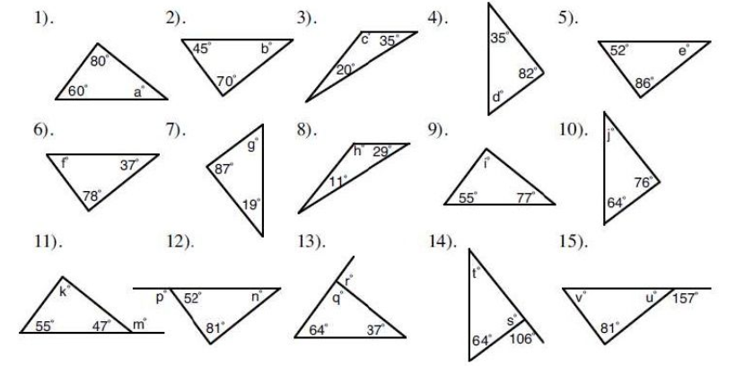
1) a = 40° | 2) b = 35° | 3) c = 125° | 4) d = 53° | 5) e = 42°
6) f = 65° | 7) g = 74° | 8) h = 140° | 9) I = 48° | 10) j = 40°
11) k = 78°  m = 133° | 12) n = 47°  p = 128° | 13) q = 79°  r = 101° | 14) s = 74°  t = 42° | 15) u = 23°  v = 76°

Pythagorean Theorem
- Watch the following video on Pythagorean Theorem and as you’re watching, answer the questions and fill in the right-hand column of the table with the math they show in the video (take notes). You may need to pause the video or watch multiple times. https://www.youtube.com/watch?v=WqhlG3Vakw8

  - What does the Pythagorean Theorem describe?
The geometric relationship between the sides of a right angle triangle
  - Fill in the blanks for the definition :

For a right triangle with ___sides (legs) ___ a and b and ________hypotenuse________ c : a² + b² = c²

  - How do you identify the hypotenuse of a right triangle? What are the other two sides called?

  - Fill in the table with notes (explain in words, copy the math steps, label diagrams, etc)
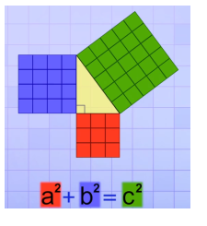 | a² + b² = c²  3² + 4² = 5²  9 + 16 = 25  25=25
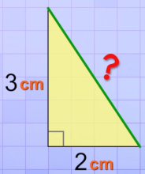 | a² + b² = c²  2² + 3² = c²  4 + 9 = c²  13 = c²  c = $\sqrt{13}$ or 3.6
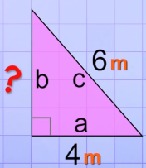 | a² + b² = c²  4² + b² = 6²  16 + b² = 36  b² = 20  b = $\sqrt{20}$ or 4.5
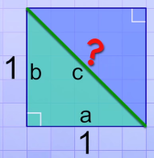 | a² + b² = c²  1² + 1² = c²  1 + 1 = c²  2 = c²  c = $\sqrt{2}$ or 1.4
a² + b² = c²
3² + 3²  9 + 9  18 | 4²  16  16

left side does not equal the right side, so this is not a right triangle, it doesn’t work in the Pythagorean Theorem

- Watch these short videos that help describe Pythagorean Theorem. Describe what’s happening in each video and how they help you understand the relationship between the sides and hypotenuse of a right triangle.
  - Video 1: https://www.youtube.com/watch?v=CAkMUdeB06o

  - Video 2: https://www.youtube.com/watch?v=KHJRDSP5I8E
Both videos show the relationship between the two “legs” and the hypotenuse of a right triangle. The area (or the side squared) of each leg, is equal to the area (or hypotenuse squared) of the hypotenuse.

- Find the missing side length:
a) a² + b² = c²  4² + 3² = c²  16 + 9 = c²  25 = c²  c = $\sqrt{25}$ or 5 |  | b) a² + b² = c²  5² + 9² = c²  25 + 81 = c²  106 = c²  c = $\sqrt{106}$ or 10.3 | c) a² + b² = c²  8² + 6² = c²  64 + 36 = c²  100 = c²  c = $\sqrt{100}$ or 10
d) a² + b² = c²  9² + x² = 15²  81 + x² = 225  x² = 144  b = $\sqrt{144}$ or 12 | e) a² + b² = c²  5² + x² = 9²  25 + x² = 81  x² = 56  b = $\sqrt{56}$ or 7.5 |  |  | f) a² + b² = c²  5² + x² = 10²  25 + x² = 100  x² = 75  b = $\sqrt{75}$ or 8.7

- Application questions: For the following questions, draw a diagram if one isn’t provided and then solve the problem.
  - A triangle has dimension 10cm x 12cm x 15cm. Is it a right triangle? Justify your answer (prove it with math).
a² + b² = c²
10² + 12²  100 + 144  244 | 15²  225  225
left side does not equal the right side, so this is not a right triangle, it doesn’t work in the Pythagorean Theorem

  - A carpenter is building a wheelchair ramp 13m long from the ground to the door. If the height of the door is 4.5m off the ground, what is the length along the ground from the building to the end of the ramp?
a² + b² = c²
4.5² + x² = 13²
20.25 + x² = 169
x² = 148.75
b = $\sqrt{148.75}$
b = 12.2 m
  - A ship leaves the port and travels 20 km north and then 13 km east. What distance is the ship from the port?
a² + b² = c²
20² + 13² = c²
400 + 169 = c²
c² = 569
c = $\sqrt{569}$
c = 23.9 km
  - The rectangle PQRS represents the floor of a room 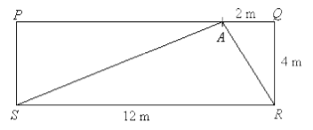
Sarah stands at point A. Calculate her distance from the corner R of the room and the corner S of the room.
From A to R  a² + b² = c²  2² + 4² = c²  4 + 16 = c²  c² = 20  c = $\sqrt{20}$  c = 4.5 m | From A to S  a² + b² = c²  4² + 10² = c²  16 + 100 = c²  c² = 116  c = $\sqrt{116}$  c = 10.8 m

  - A wooden box measures 4m × 3m × 2m. What is the longest straight pole? (shown in the picture) that can fit from one corner to the opposite corner inside the box?
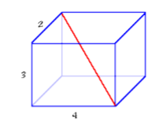 | a² + b² = c²  3² + 4² = c²  9 + 16 = c²  c² = 25  c = $\sqrt{25}$  c = 5 m | a² + b² = c²  2² + 5² = c²  4 + 25 = c²  c² = 29  c = $\sqrt{29}$  c = 5.4 m

  - In a flyer, a TV is listed as being 55”. This distance is the diagonal distance across the screen. If the screen measures 28” in height, will the TV fit on my TV stand, which is 48” wide?
a² + b² = c²
28² + b² = 55²
784 + b² = 3025
b² = 2241
b = $\sqrt{2241}$
b = 47.3”
So yes, the TV will fit on the TV stand

  - Keisha is a volunteer with the Ecology Action Centre’s Urban Garden Project in NS. She is creating a traditional Acadian garden behind a house in West Pubnico. The garden will feature the kinds of herbs many Acadians grew when they first settled in the area in 1653, including lovage, raifort, chamomile, thyme, and valerian. Keisha is responsible for two triangular sections of earth, one on each side of the porch
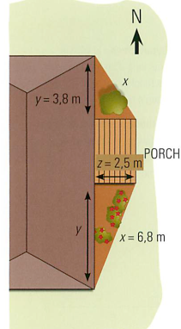 | a) Given the dimensions of the legs of the triangle as shown in the diagram, what will be the length of the hypotenuse of the plot to the north of the porch?  a² + b² = c²  3.8² + 2.5² = c²  14.44 + 6.25 = c²  c² = 20.69  c = $\sqrt{20.69}$  c = 4.5 m  b) How far along the back of the house will the garden in the plot to the south of the porch reach?  a² + b² = c²  2.5² + b² = 6.8²  6.25 + b² = 46.24  b² = 39.99  b = $\sqrt{39.99}$  b = 6.3 m

  - Marc is going to paint the exterior of his house. He has a 40 ft ladder and knows that for safety reasons the base of the ladder must be between 9 and 12 feet from the base of the wall. What are the maximum and the minimum heights the ladder will reach up the wall?
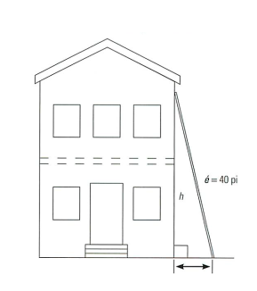 | When the base is 9 feet away…  a² + b² = c²  9² + b² = 40²  81 + b² = 1600  b² = 1519  b= $\sqrt{1519}$  b = 39 ft (maximum height)  When the base is 12 feet away…  a² + b² = c²  12² + b² = 40²  144 + b² = 1600  b² = 1456  b = $\sqrt{1456}$  b = 38.2 ft (minimum height)

  - Al has been contracted to build a garage for an adventure company on Grand Manan Island, NB. The company will use the garage to store their bicycles. The garage will be 7.5 m wide and the roof will have a 0.6 m overhang.
a) If the peak of the garage is 1.2m higher than the walls, how long does the rafter on each side have to be?
a² + b² = c²
1.2² + 3.75² = c²
1.44 + 14.06 = c²
c² = 15.5
c = $\sqrt{15.5}$
c = 3.9 m
Plus the overhang = 4.5 m
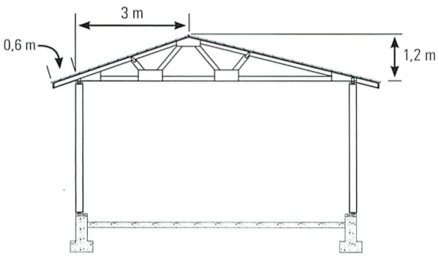 | b) The owner changes his mind and wants the peak to be off-centre. If it is 3m from one side, how long will Al have to make each of the rafters? Note: There will still be a 0.6m overhang.
 | a² + b² = c²  3² + 1.2² = c²  9 + 1.44 = c²  c² = 10.44  c = $\sqrt{10.44}$  c = 3.2 m  3.2 + 0.6 = 3.8 m | a² + b² = c²  1.2² + 4.5² = c²  1.44 + 20.25 = c²  c² = 21.69  c = $\sqrt{21.69}$  c = 4.7 m  4.7 + 0.6 = 5.3 m

  - The roof of a shed is offset as in the diagram shown. Ben must determine its measurements so that he can order materials to repair it.
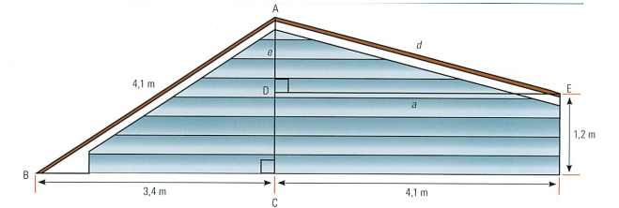
a) How high is the peak (AC)?
a² + b² = c²
3.4² + b² = 4.1²
11.56 + b² = 16.81
b² = 5.25
b = $\sqrt{5.25}$
b = 2.3 m

b) What is the length of the right-hand side (AE)?
a² + b² = c²
1.1² + 4.1² = c²
1.21 + 16.81 = c²
c² = 18.02
c = $\sqrt{18.02}$
c = 4.2 m

  - Suzanne is designing a rectangular storage box. The box will be built of solid oak. The lid of the storage box will extend above the sides by 10 cm. Each face except the bottom will have an embedded X made of thick copper wire as shown in the diagram. How much copper wire must Suzanne buy if the storage box is 90 cm long, 70 cm deep and 70 cm high?
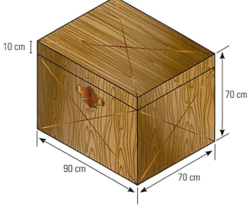 | TOP:  a² + b² = c²  70² + 90² = c²  4900 + 8100 = c²  c² = 13000  c = $\sqrt{13000}$  c = 114 cm  x 2 wires = 228 cm
LONGER SIDE:  a² + b² = c²  60² + 90² = c²  3600 + 8100 = c²  c² = 11700  c = $\sqrt{11700}$  c = 108.2 cm  x 2 wires= 216.4 cm  x 2 sides= 432.8 cm | SHORTER SIDE:  a² + b² = c²  60² + 70² = c²  3600 + 4900 = c²  c² = 8500  c = $\sqrt{8500}$  c = 92.2 cm  x 2 wires = 184.4 cm  x 2 sides = 368.8 cm
228 + 432.8 + 368.8 = 1029.6 cm
Suzanne needs approximately 1030 cm of copper wire.

Last year’s angle puzzle bonus question: (this is EXTRA, for those of you who like a challenge )
A protractor will not help you here, the diagram is not exact. You will need to use your knowledge of triangles and angles (types, corresponding angles, supplementary angles, vertically opposite angles, triangle angles add to 180°, quadrilateral angles add up to 360°)
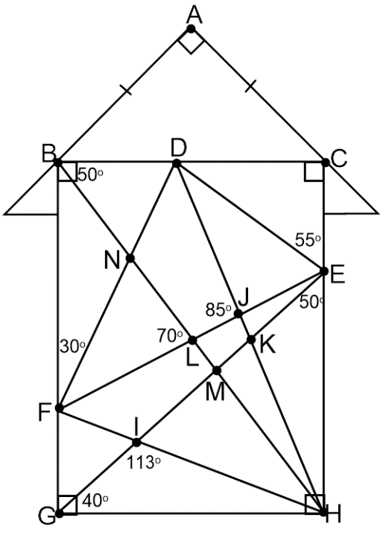 | 1. Classify the following triangles by side and angle  - ∆ ABC : ___right isosceles__  - ∆ BGH : ___ right scalene____  - ∆ DEJ : ___obtuse scalene______  - ∆ BDH : __ obtuse scalene ___  - ∆ IGH : __ obtuse scalene __  - ∆ BFL : ___ acute isosceles ___  - ∆ HKM : ___ right scalene __  2. What are the following angle measurements? (the middle letter in the name of the angle is the vertex)  - ∠ BAC = __90°___ - ∠ EIF = __113°___ - ∠ CDE = __35°___ - ∠ DJE = __95°___ - ∠ DCE = __90°___ - ∠ ABC = __45°___ - ∠ ACB = __45°___ - ∠ FBL = __40°___ - ∠ BFL = __70°___ - ∠ BNF = __110°___ - ∠ BFN = __30°___ - ∠ FGI = __50°___ - ∠ GFI = __63°___ - ∠ FIG = __67°___ - ∠ HIM = __67°___ - ∠ GIH = __113°___ - ∠ GHI = __27°___ - ∠ FHL = __23°___ - ∠ BHD = __15°___ - ∠ EDF = __85°___ - ∠ DNL = __110°___ - ∠ CHD = __25°___ - ∠ EKH = __105°___ - ∠ GKH = __75°___ - ∠ EMH = __90°___ - ∠ GMH = __90°___ - ∠ BMG = __90°___ - ∠ BME = __90°___ - ∠ DKE = __75°___ - ∠ FLH = __110°___ - ∠ ELH = __70°___ - ∠ BLE = __110°___ - ∠ BDJ = __115°___ - ∠ FNL = __70°___ - ∠ EJK = __85°___ - ∠ FEG = __20°___ - ∠ DKG = __105°___ - ∠ FJH = __95°___ - ∠ DEF = __55°___ - ∠ EDJ = __30°___ - ∠ BDF = __60°___ - ∠ BND = __70°___ - ∠ BHG = __50°___

*always a possibility I made errors, so if you got something different than I did and think you’re right, please let me know so I can check!

