GMF 10 Week 4 (April 27-May1, 2020)

Instructions: Please complete the following questions by researching online and watching video links. Please reach out to your teacher for help or guidance through email or Teams if needed. Live video tutorials are on Teams Wednesdays at 11am and will be recorded and posted on Teams to watch at your convenience.
Trigonometry
Watch the following videos and fill in the notes / answer the questions.
- Labelling sides
https://www.youtube.com/watch?v=1ALLrv2dQxc
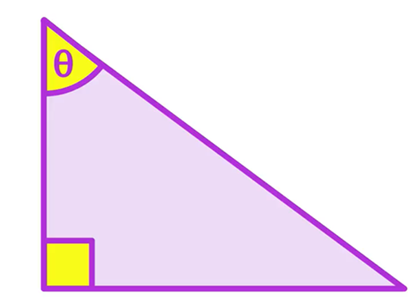 | What type of triangle is this? How do you know?
This is the Greek letter called: _________

It is used as a variable to represent: ____________
It is the _________ side
It is always opposite the ____________________.
Opposite the angle we’re _________________
or
Opposite the angle we _____
The one “____________”
The side next to the _______________ and the angle involved in the question
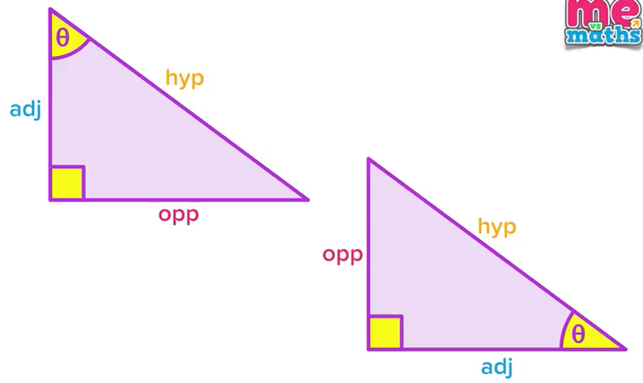 | Which side name stayed the same in both triangles?  Why did the “opp” and “adj” sides swap?
label the diagram with “hyp”, “opp” and “adj”

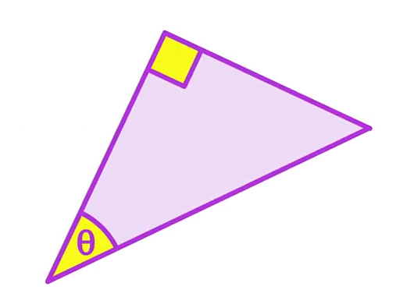

Label the following triangles with “hyp”, “opp” and “adj” (in reference to the indicated angle)

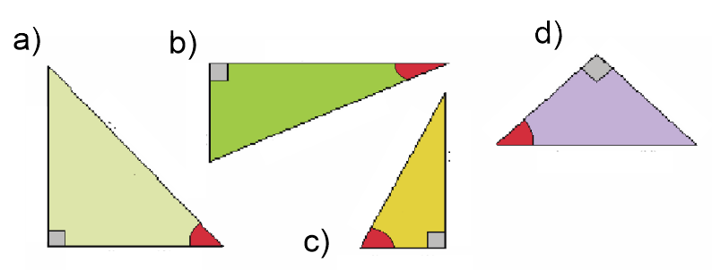

adj
opp
hyp
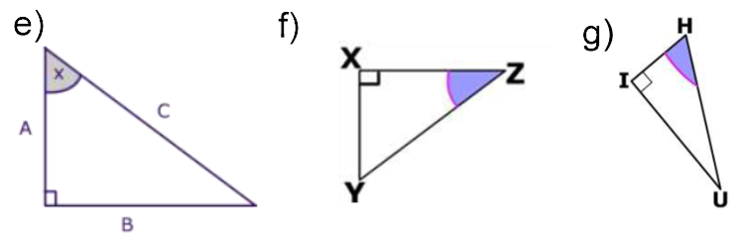

- Intro Trig ratios/identities/formulas
https://www.youtube.com/watch?v=tKAMM3kacbs

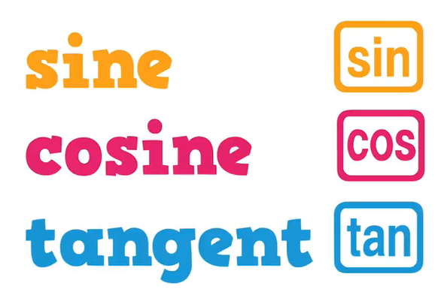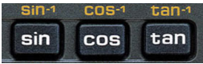 | Find these 3 buttons on your calculator.
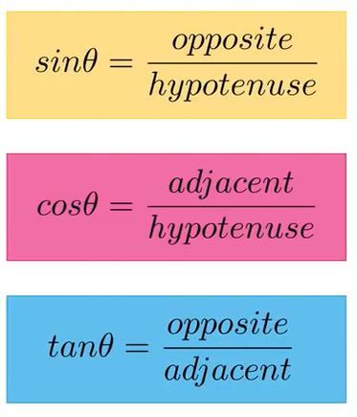 | These are the 3 Trig formulas.  What is the phrase used to remember the formulas?
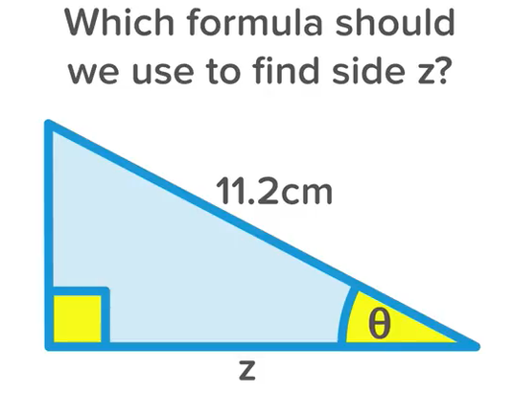 | Label each side (hyp, opp, adj)  Which two sides of this triangle are “active”?  Which formula uses both of those “active” sides?
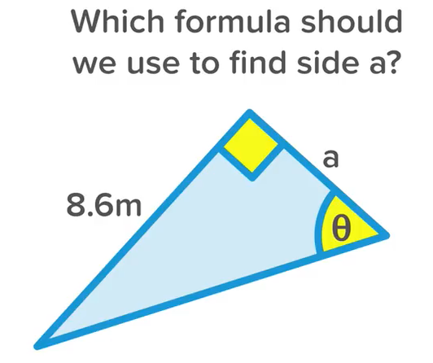 | Label each side (hyp, opp, adj)  Which two sides of this triangle are “active”?  Which formula uses both of those “active” sides?

For the following questions, label each side (hyp, opp, adj) and decide which of the three trig formulas you would use, based on the “active” sides.

adj
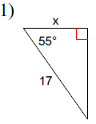  opp  hyp | formula to be used:  cos$θ$=$\frac{adj}{hyp}$ | 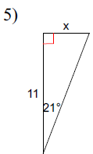 | formula to be used:
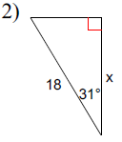 | formula to be used: | 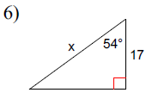 | formula to be used:
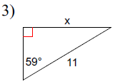 | formula to be used: | 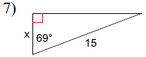 | formula to be used:
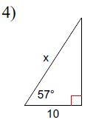 | formula to be used: | 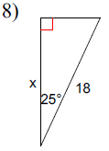 | formula to be used:

- Finding missing sides

*** BEFORE YOU START THIS SECTION, AND USING THE SIN COS TAN BUTTONS ON YOUR CALCULATOR, YOU HAVE TO MAKE SURE YOUR CALCULATOR IS IN DEGREE MODE – look for a little D or DEG on your screen, if it shows R or RAD or G or GRAD, hit your “mode” button until it’s in degree mode, IF YOU AREN’T IN THE RIGHT MODE, YOUR ANSWERS WILL BE WRONG.

https://www.youtube.com/watch?v=E7y3ENOSGK4

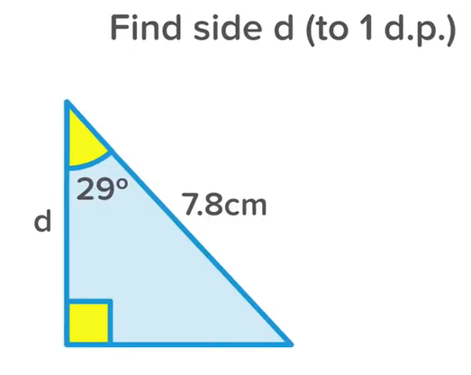  adj  opp  hyp | Example: Label the sides  Which two sides are “active”?  adj (because it has the variable “d” and hyp because it has a measurement.  formula:  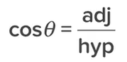  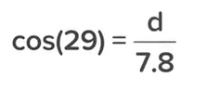  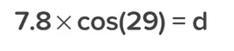  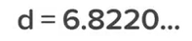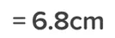
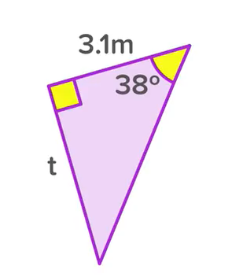 | Label each side.  Explain why the correct formula is 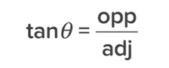  Show the steps of how to get the missing side length “t”
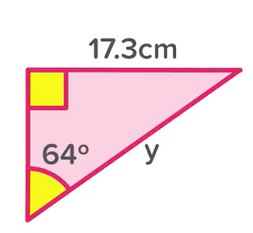 | Label each side  Explain why the correct formula is  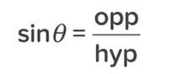  Show the steps of how to get the missing side length “y”  ***note, if you want to do the math a different way (that is still mathematically correct), you can do it your own way. The math shown in the video is a short-cut, short cuts are good, but sometimes confusing. Just make sure you can do it in a way that arrives at the correct answer
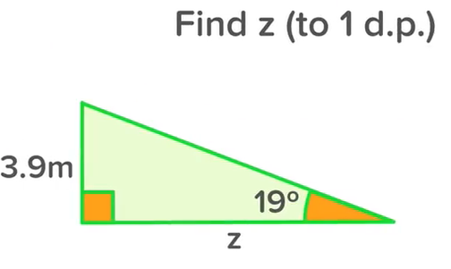 | Label each side  Explain why the correct formula is  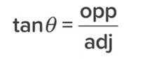  Show the steps of how to get the missing side length “z”

Find the missing side lengths in the following triangles. For every question, label your sides and write your formula. Round answers to one decimal place.
adj  opp  hyp | cos$θ$=$\frac{adj}{hyp}$  $$\cos{55}=\frac{x}{17}$$  $$0.5735=\frac{x}{17}$$  (if you are going to round off like I did, make sure you use at least 4 decimals)  x = 9.8

I’m going to post the answers (without the work) below so you know if you did the questions correctly or not.
