Online GMF Review (this is from the review for last year’s midterm, please omit #4 and #5)
- Draw each type of angle and label them. (acute, straight, obtuse, right, reflex)

- Write the complementary angles of the following angles:
  - 15° : _________
  - 45° : _________
  - 75° : _________

- Write the supplementary angles of the following angles:
  - 15° : _________
  - 45° : _________
  - 75° : _________

- Measures the following angles with a protractor:
  - B.

- Bissect 4a with a protractor and 4b with a compass.
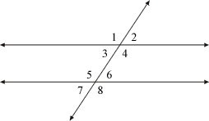
- Use the diagram to answer the following questions:
  - Identify 2 angles that are:
    - Vertically opposite: _______ and _______
    - Corresponding: _______ and _______
    - Interior: _______ and _______
    - Exterior: _______ and _______
    - Alternate-interior: _______ and _______
    - Alternate-exterior: _______ and _______
  - If angle #1 is 150° what is the angle value #5? Why?

  - If angle #7 is 58° what is the angle value #2? Why?

  - If angle #6 is 40° what is the angle value #4? Why?

  - If angle #5 is 115° what is the angle value #4 Why?

- Find the value that's missing:
  - 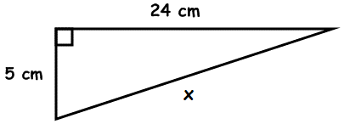 B.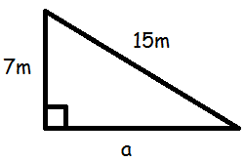

- Are the following dimensions the sides of a right triangle? Justify your answers (prove).
  - 7.5 cm x 10 cm x 12.5 cm b. 10.5 m x 14 cm x 19.5 cm

- A ship leaves the port and sails 40 km north, then 15 km to the west. How far from the port is the ship?

- Luke is preparing to paint the outside of his house. He has a 35 ft ladder and knows that, for safety reasons, the base of the ladder must be 8 to 11 feet from the base of the wall. What are the maximum and minimum heights that the ladder will reach on the wall?

- Classify the triangles according to their sides and angles:
  - 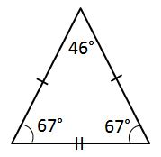 b. 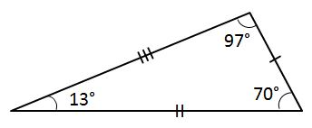 c.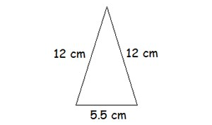

- Find the values that are missing:
  - 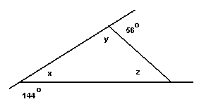b. 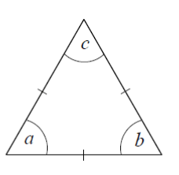c. 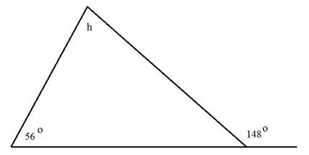

- Find the missing sides or angles:
  - 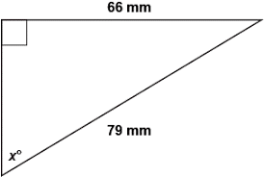b. 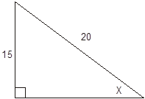c.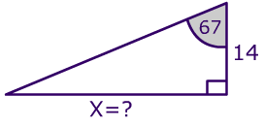

D. 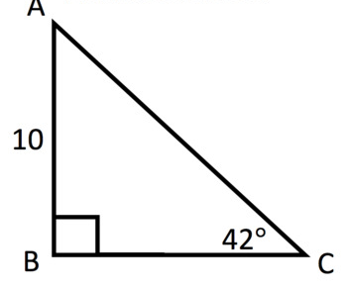 E. 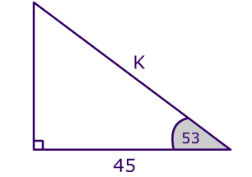
Has

- The angle of depression from the top of a cliff to a sailboat below is 30°. If the sailboat is 300 m from the base of the cliff, how high is the cliff?

- Michael has a summer job working for a business that makes antenna towers. He must determine the length of the guy wire needed to stabilise the 30 m tall antenna tower. The guy wire must form a 65° angle with the ground. Draw a diagram, label it, and calculate the length of the required wire.

- A builder wants to build a 10.8 m long ramp that reaches a height of 2.5m relative to the ground. Calculate the angle the ramp should make with the horizontal.

